
Second Semester
CSE
CS3401 - Model Examination
(Regulation 2023)
Time: Three Hours | Maximum Marks: 100 Marks
 | PART- A | (10 x 2 = 20 Marks)
Q.No. | Answer ALL Questions | CO | BTL | Marks
1 | The relationship between Young’s modulus (E), Bulk modulus (K) and Poisson’s ratio (µ) is given by? Justify your answer. a) E=2K(1-2µ) b) E=3K(1-2µ) c) E=2K(1-2µ) d) E=2K(1-3µ) | CO1 | 4 | 2
2 | Recall the term poisson's ratio and write their formula. | CO1 | 1 | 2
3 | False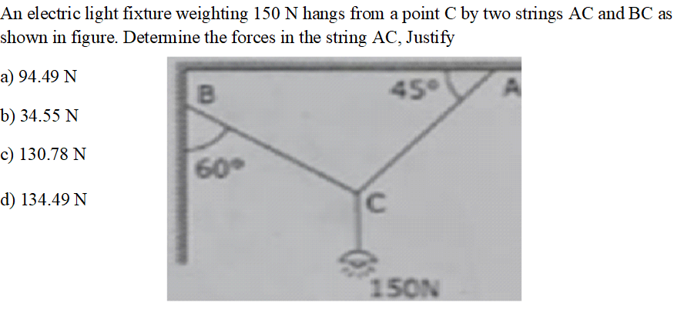 | CO2 | 3 | 2
4 | Compare the like collinear and unlike collinear force | CO2 | 4 | 2
5 | The angular displacement of a body in rotational motion is measured in: Justify.  a) meters  b) degrees  c) radians  d) revolutions per minute | CO3 | 4 | 2
6 | Releat the range of a projectile in parabolic curve of curvilinear motion. | CO3 | 4 | 2
7 | Which theorem is used to calculate the Moment of Inertia of a composite area about its final centroidal axis by transferring the Moment of Inertia of its constituent parts? Justify your answer. a) Parallel Axis Theorem b) Perpendicular Axis Theorem c) Principle of Superposition d) Moment of Area Theorem | CO4 | 4 | 2
8 | Analyze the basic elements of truss and their types. | CO4 | 4 | 2
9 | Power transmitted by a shaft is given by. Justify your answer.  a) P = 2πNT/60  b) P = T/2πN  c) P = TN/60  d) P = 2πT/N | CO5 | 4 | 2
10 | Analyze the equation for power transmitted by a shaft and state its units. | CO5 | 4 | 2
 | PART- B | (5 x 16 = 80 Marks)
Q.No. | Answer All Questions | CO | BTL | Marks
11 a | A rectangular block 260 mm x 110 mm x 70 mm is subjected to axial loads as follows:  450 KN (tensile) in the direction of its length.  970 kN (tensile) on the 260 mm x 70 mm faces.  1100 kN (compressive) on the 260 mm x 110 mm faces.  Taking E = 200 GN/m² and Poisson's ratio as 0.25.  Find the following:  i. Change in volume of the block.  ii. Values of the modulus of rigidity and bulk modulus for material of the block. | CO1 | 2 | 16
(OR)
11 b | Interpretation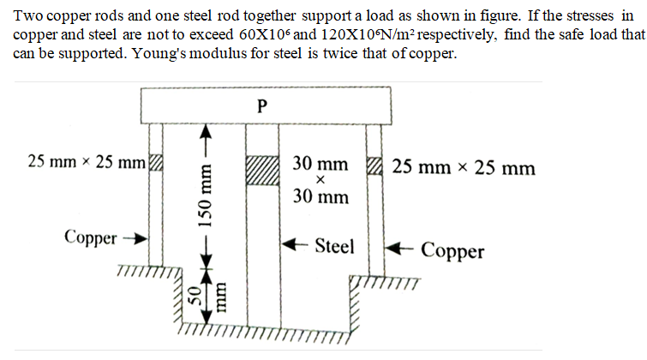 | CO1 | 2 | 16
12 a | Estimation | CO2 | 2 | 16
(OR)
12 b | Estimation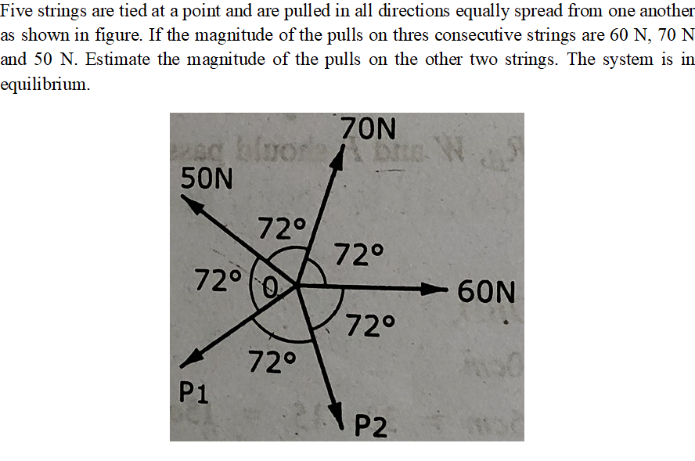 | CO2 | 2 | 16
13 a | Two trains A and B leave the same station on parallel lines. Train A starts with an uniform acceleration of 0.5 m/s² and attains a speed of 36 km/hour, when steam is reduced to keep the speed constant. Train B leaves 30 seconds after, with uniform acceleration of 1 m/s² to attain a maximum speed of 54 km/hour. Identify the time, the train A when will overtake to A? | CO3 | 3 | 16
(OR)
13 b | Derive the following equations  i. Maximum Height attained  ii. Horizontal range  iii. Maximum horizontal range | CO3 | 3 | 16
14 a | Calculation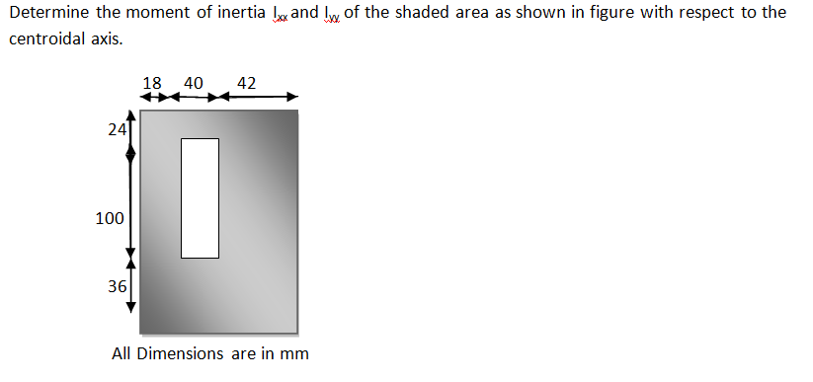 | CO4 | 3 | 16
(OR)
14 b | Calculation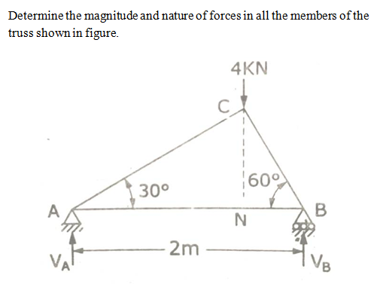 | CO4 | 3 | 16
15 a | A beam of length 6m is simply supported at the ends and carries a UDL of 1.5kN/m run and three concentrated loads of 1kN, 2kN and 3kN acting at a distance of 1.5m, 3m and 4.5m respectively from left end. Draw the SFD and BMD and determine the maximum bending moment. | CO5 | 3 | 16
(OR)
15 b | Determine the diameter of a solid shaft which will transmit 90 kW at 160 r. p. m. Also determine the length of the shaft if the twist must not exceed 1º over the entire length of the shaft. The maximum shear stress is limited to 60 N/mm². Take the vales of modulus of rigidity 8x10⁴ N/mm². | CO5 | 3 | 16

******************
QP123

